- Purpose

This document provides a description of the EPIC ClearView System and its components.

- Scope

The scope of this document encompasses the EPIC ClearView System as a whole and defines the components of the system.

3.0 Definitions
ClearView Device | The ClearView device is a galvanic skin response (GSR) measurement system pursuant to FDA classification, class II, CFR 882.1540. The intended use/indications for use for the device may differ depending on the market (e.g., US versus European). Refer to the specific ClearView software report specification for current intended use/indications for use.
Computer System | The computer system is installed with the ClearView software and works with the ClearView device to capture, store, and analyze images to measure galvanic skin response.
ClearView Report | A report produced by the ClearView software that summarizes the physical and autonomic responses, and is utilized by a licensed physician.
Capacitive Barrier | The capacitive barrier is an 80 mm clear poly circle that acts as a barrier between the moisture on a subject’s fingertips and the glass electrode of the ClearView device.
Workstation | The Workstation is a movable cart to which all other components of the ClearView System are attached allowing for the rapid transport of the ClearView system. The Workstation is an option and not considered part of the ClearView System.
- Operational Environment

The EPIC ClearView System is intended for use in a clinical environment by qualified professionals only.

- Functional Description

The EPIC ClearView System consists of the ClearView device (packaged) with USB cable and power cord; computer system including the ClearView software, monitor, keyboard and mouse; printer; uninterruptible power supply (UPS); capacitive barrier; cleaning kit; USB hardware key, and ClearView workstation. The hardware device is connected to the computer system through a USB port and plugs into a standard wall outlet power source. The ClearView software is installed onto the computer and controls the device, provides the user interface and analyzes the data to provide a ClearView Report of the GSR measurements.

The EPIC ClearView System is depicted in Figure 1:

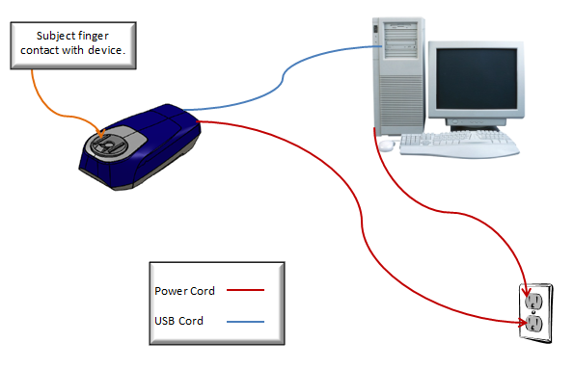

Figure 1: EPIC ClearView System

The components for the EPIC ClearView System are as follows:

  - ClearView Device (Packaged)

The hardware device includes a digital video camera, USB hub, power supply, and controller all managed by a dedicated computer system. The packaged hardware device includes a USB cable and power cord. The device is connected to the computer through a USB port. The ClearView software communicates with the device to configure camera properties which control the image capture process. In addition to setting up the various control parameters, the software supports initializing and resetting the device.

  - Computer System

The computer system is installed with the EPIC ClearView software and works with the EPIC ClearView device to capture, store, and analyze images to measure galvanic skin response. The computer system is a dedicated business-class computer system and detailed specifications are defined in Computer System, 1282-1511 in the EPIC quality system. The minimum specifications are:

- Operating System: Microsoft Windows XP Professional Service Pack 4
- Processor: Intel Core™ Duo T7250 2Ghz
- Memory: 2GB RAM

The primary application running on the computer system is ClearView software. The ClearView software is used to provide the following functionality:

- Control the device for calibration and patient scanning.
- Manage patient demographic and test configuration data.
- Manage security to control access to data.
- Perform analysis on the captured images.
- Store raw data analysis and final results in a database.
- Present results to end user in a printable report.
- Securely save the results for future use and reference.

This functionality is divided into device functions controlled by software and user features provided by software.

  - Printer

The printer is connected to the computer system and produces color copies of the ClearView Report from the EPIC ClearView software.

  - Uninterruptible Power Supply (UPS)

The uninterruptible power supply offers medical-grade UPS protection for the ClearView device and computer system. The UPS protection has built-in interactive voltage regulation, intelligent monitoring and unattended shutdown capability. It provides uninterruptible power for the device and computer system when they are unplugged and moved from one location to another.

  - Capacitive Barrier

The capacitive barrier is a plastic filter that is placed directly on the glass electrode surface of the ClearView device and creates a barrier between the patient’s finger and the glass electrode. The thickness of the barrier is minimized to ensure accurate energized image capture. The capacitive barriers are used to increase the capacitance of the subject being measured which provides the ability to assess the implications/impact of the autonomic nervous system on measurement outputs.

  - Cleaning Kit

The cleaning kit consists of cleaning cloths and alcohol swabs for removing surface contaminants on the glass lens of the device that could create artifacts in the image. The cleaning cloths are 2-ply strength, 100% recycled, white facial tissue and the alcohol swabs are individually wrapped 70% isopropyl alcohol-soaked cotton swabs. All cleaning items are contained in a container for easy access and storage.

  - USB Hardware Key

The USB hardware key prevents unauthorized use of the ClearView System by untrained personnel. When attached to the computer, the hardware key monitors and enforces the licensing of the ClearView System.

  - ClearView Workstation

The ClearView workstation is a cart system that includes all components that physically support the EPIC ClearView System. The components are the Workstation on Wheels, custom printer platform, custom 4-channel Apollo track with shuttle, zero-limb arm, three-limb arm, and ClearView device platform. The workstation is capable of moving to different locations, has appropriate cord management, and provides electrostatic discharge protection for equipment and device. It adjusts to allow user access to the entire ClearView System while standing, and adjusts the device position to accommodate subjects while sitting, standing or lying down.

- References

ClearView System Diagram, CLV-100
EPIC ClearView Software Description, SD-001
EPIC ClearView Computer, 1282-1511
Printer, 1282-1513
Uninterruptable Power Supply, 1282-1514
Cleaning Cloth, 1282-1500
70% Isopropyl Alcohol Swabs, 1282-1504
Capacitive Barrier, 1282-1025
USB Hardware Key, 1282-1515
ClearView Workstation, WOW-100
Document Revision History
Version Number: | Description of Change: | Date: | Updated By:
000 | New Document |  | J. Ayres

